**Ideation Phase:**

**Brainstorm & Idea Prioritization Template**

|  |  |
| --- | --- |
| Date | 26 June 2025 |
| Team ID | LTVIP2025TMID30678 |
| Project Name | To Supply Leftover Food to Poor |
| Team members | 1)Sadi ramana (Leader) – 22MH1A04D6   * [Ramanarebel69@gmail.com](mailto:Ramanarebel69@gmail.com)   2)Sravani kasireddy (Documentation developer and opearator ) - 23MHA0412   * [Sravanikasireddy850@gmail.com](mailto:Sravanikasireddy850@gmail.com) |

**Brainstorm & Idea Prioritization Template**:

Think about coming up with ideas like organizing food drives, collaborating with nearby eateries and supermarkets to donate food, and developing a community app for food sharing in order to efficiently provide surplus food to those in need. To optimize efficacy, rank these concepts according to their viability, significance, and community involvement.

**Step-1: Team Gathering,**

**Collaboration and Select the Problem Statement**:

Team Gathering:

1. Identify Stakeholders: Engage team members from diverse backgrounds including community leaders, volunteers, local businesses, and non-profit organizations.

2. Set a Meeting Agenda: Define the agenda of the meeting, which is brainstorming and choosing a clear problem statement.

3. Choose a Collaborative Environment: Utilize tools such as whiteboards, sticky notes, or digital collaboration platforms (e.g., Miro, Google Jamboard) to provide a conducive discussion environment.

Collaboration:

1. Brainstorming Session: Ask team members to present their ideas and experiences concerning food wastage and hunger in the community.

2. Identify Key Issues: Identify the key issues involved in providing leftover food, including logistics, food safety, and public awareness.

3. Gather Data: Study statistics regarding food wastage and hunger in your community to inform the discussion.

Problem Statement Selection:

1. Write Problem Statements: From the brainstorming session, write out a few possible problem statements. For instance:

- "How can we gather and redistribute excess food from nearby restaurants to needy individuals in our community?"

- "What mechanisms can be put in place to have safe and effective transportation of excess food to food-scarce groups?"

- "How can we empower the community and raise awareness towards reducing food waste and helping the needy?"

2. Prioritize Statements: Rank the problem statements based on criteria like impact, feasibility, and community engagement.

3. Select the Final Problem Statement: Pick one concise and clear problem statement that the team will work on. For instance:

- "Create a model for sustainable collection and distribution of excess food from neighboring businesses to food-insecure individuals within our community."

Next Steps:

- Delegate roles and responsibilities for conducting additional research and developing an action plan based on the chosen problem statement.

- Schedule next meetings to monitor progress and make necessary adjustments.



**Step-2: Brainstorm, Idea Listing and Grouping**:

Here's a systematic step-by-step process of brainstorming, listing, and clustering ideas for donating excess food to the needy:

Brainstorming Session:

Take a diverse group of stakeholders (volunteers, local businesses, community leaders) and have an open discussion. Use a whiteboard or a digital platform to jot down all ideas.

Idea Listing:

1.Local Business Partnerships:

- Partner with restaurants and grocery stores for food donation.

- Develop a network of nearby farms for excess produce.

2. Food Recovery Programs:

- Form a food rescue volunteer team that goes out to gather excess food.

- Establish a mobile app for businesses to indicate excess food availability.

3. Community Engagement:

- Conduct campaigns for raising awareness of food loss and hunger.

- Organize community events for public education on food donation procedures.

4. Food Distribution Procedures:

- Establish food distribution sites at community centers or churches.

- Create a delivery system for those who cannot visit distribution sites.

5. Food Safety and Compliance with Regulations:

- Offer volunteers training in food safety and handling.

- Coordinate with local health agencies to develop compliance with food safety laws.

Grouping Ideas:

After organizing ideas in a list, categorize them for easier management:

1.*Partnerships and Collaborations:

- Network with restaurants and grocery stores.

- Partner with local farms.

2. Logistics and Distribution:

- Food recovery programs.

- Methods of distribution (points and delivery systems).

3. Community Involvement:

- Awareness campaigns.

- Community events.

4. Safety and Compliance:

- Food safety training.

- Compliance with the law.

5. Sustainability

- Composting programs.

- Sustainable packaging.

Next Steps:

*Prioritize Ideas: Prioritize each idea against feasibility, impact, and community interest.

*Action Plan: Create a detailed action plan for the highest-priority ideas, allocating roles and responsibilities.

*Follow-up*: Hold regular meetings in order to monitor progress and make necessary changes.

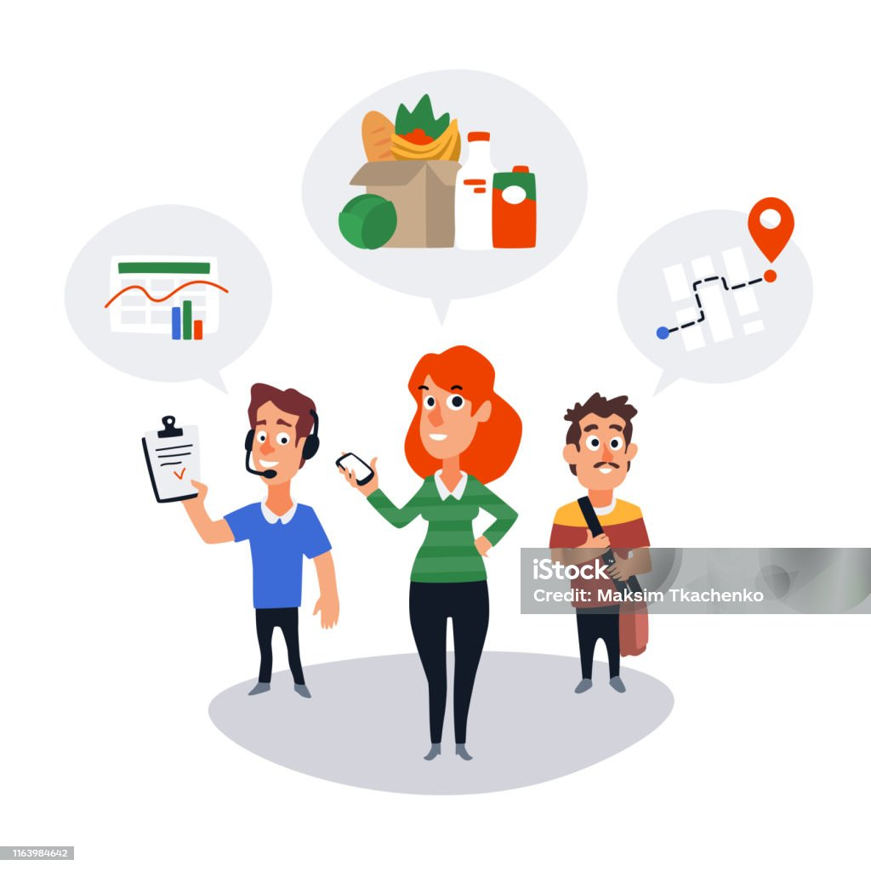

**Step-3: Idea Prioritization:**

To rank ideas on how to provide excess food to the poor, you can follow a structured method where you score each idea against certain criteria. Here is a step-by-step process to assist you in ranking:

Step 1: Define Evaluation Criteria

Formulate criteria to measure the ideas. Typical criteria are:

1. Impact: Potential impact on food waste reduction and hunger relief.

2. Feasibility: Ease of implementing the idea, factoring in resources, time, and logistics.

3. Community Engagement: The capacity to engage and mobilize the community.

4. Sustainability: Long-term sustainability of the initiative.

5. Cost: The cost implications and funding needs.

Step 2: List Ideas

Some ideas to think about for providing leftover food to the poor are:

1. Partnerships with Local Businesses

2. Food Recovery Programs

3. Community Engagement Campaigns

4. Distribution Points in Community Centers

5. Mobile App for Food Donations

6. Food Safety Training for Volunteers

7. Composting Initiatives

8. Support Fundraising Events

Step 3: Analyze Results

-Top Ideal: Find ideas that have the top total scores. Here, "Partnerships with Local Businesses" and "Food Recovery Programs" both had a score of 21, so they are the top contenders.

*Ties: In the event of a tie, take into account other factors like urgency or fit with community needs.

Step 4: Develop Action Plans:

For the highest-priority ideas, develop thorough action plans with steps for implementation, roles and responsibilities, and timelines.

